World Cup Stadium seating capacity, history:
- Estadio Azteca (Mexico City)
- MetLife Stadium (New York/New Jersey)
- AT&T Stadium (Dallas)
- Mercedes-Benz Stadium (Atlanta)
- SoFi Stadium (Los Angeles)
- BMO Field (Toronto)
- BC Place (Vancouver)
Estadio Azteca (Mexico City)
- Seating Capacity: Approximately 87,523 currently, with planned expansion to around 90,000 after renovations.
- History: Opened in 1966, famous for hosting two World Cup finals (1970 and 1986), including iconic moments like Pelé's and Maradona's legendary performances.
- Renovations: Undergoing major upgrades for the 2026 World Cup, including seating reconfiguration, new LED screens, roof repairs, improved locker rooms, and modernized fan amenities.
- Photos: High-resolution photos available showing historic and modern views inside and outside the stadium.^{[1][2][3][4][5]}

Estadio Azteca.
Pelé held aloft by a crowd after winning the 1970 FIFA World Cup final in Mexico City.

Argentine player Diego Maradona hoists the FIFA World Cup trophy while being carried on shoulders at Azteca Stadium.
MetLife Stadium (New York/New Jersey)
- Seating Capacity: Around 82,500.
- History: Opened in 2010, home to the NFL’s New York Giants and Jets, modern multipurpose stadium.
- Renovations: Continuously updated with latest fan experiences, technology, and hospitality suites.
AT&T Stadium (Dallas)
- Seating Capacity: Approx. 80,000 (expandable to ~100,000 with standing room).
- History: Opened in 2009, home of the Dallas Cowboys, known for its massive retractable roof and large center-hung video screen.
- Renovations: Upgraded technologies and seating comfort improvements ongoing.
Mercedes-Benz Stadium (Atlanta)
- Seating Capacity: Around 71,000-75,000.
- History: Opened in 2017, home to Atlanta Falcons and Atlanta United FC.
- Renovations: Equipped with advanced retractable roof, 360° LED halo board, premium amenities.
SoFi Stadium (Los Angeles)
- Seating Capacity: Approx. 70,000 (expandable).
- History: Opened in 2020, home to LA Rams and Chargers, state-of-the-art design.
- Renovations: New stadium with cutting-edge technology, premium seating, and fan zones.

BMO Field (Toronto)
- Seating Capacity: About 30,000.
- History: Opened in 2007, home to Toronto FC MLS team, known for a soccer-specific design.
- Renovations: Expanded and modernized for enhanced fan experience, including a canopy and better sightlines.
BC Place (Vancouver)
- Seating Capacity: Approx. 54,500.
- History: Opened in 1983, renovated extensively including a retractable roof added in 2011.
- Renovations: Latest upgrades for FIFA standards and fan comfort ahead of the World Cup.
If desired, specific high-resolution photos for any of these stadiums can be shared upon request.^{[4][6][8][9][10]}
Would you like detailed photos or architectural renderings for any particular stadium from this list?

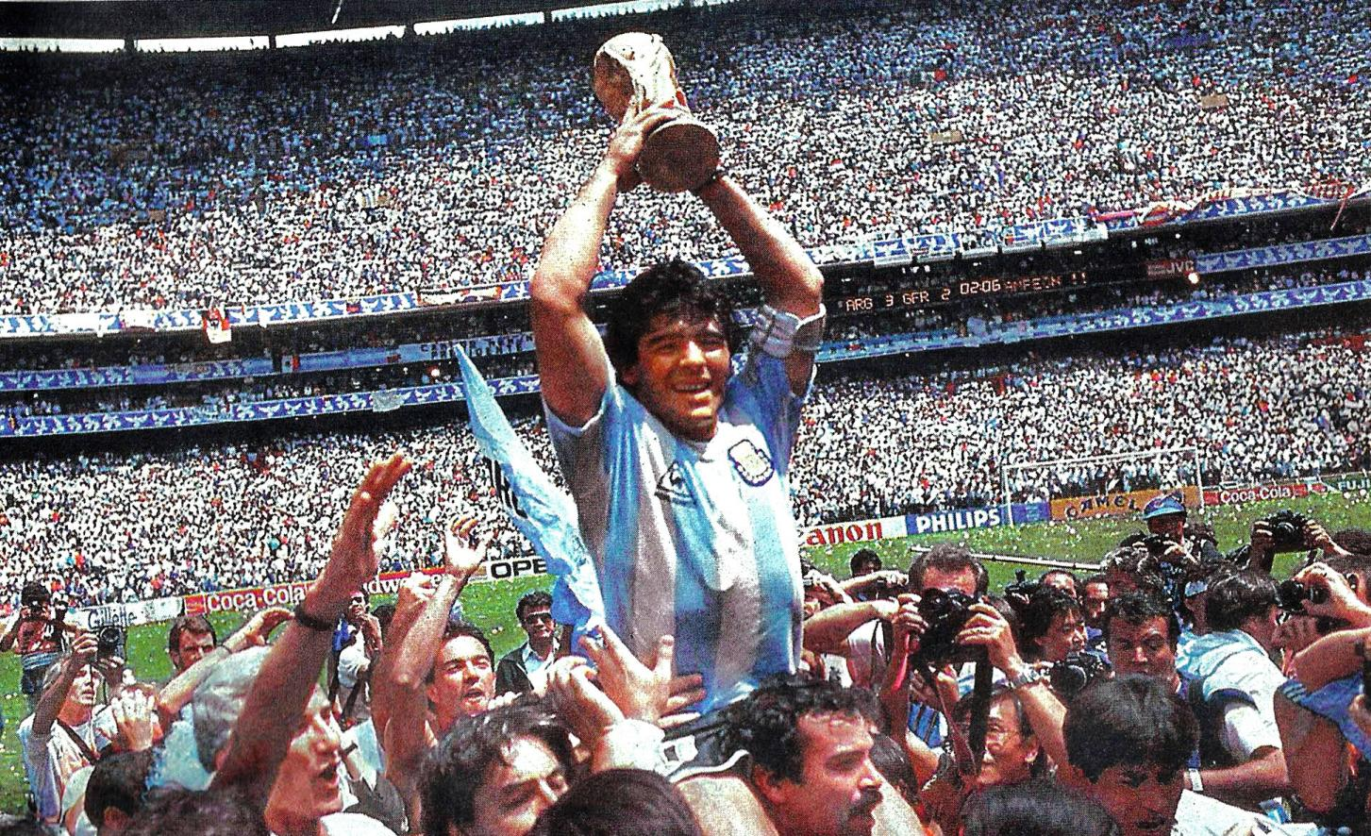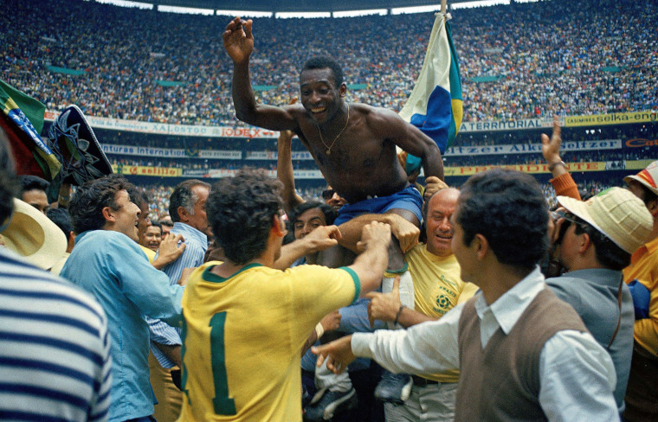

- 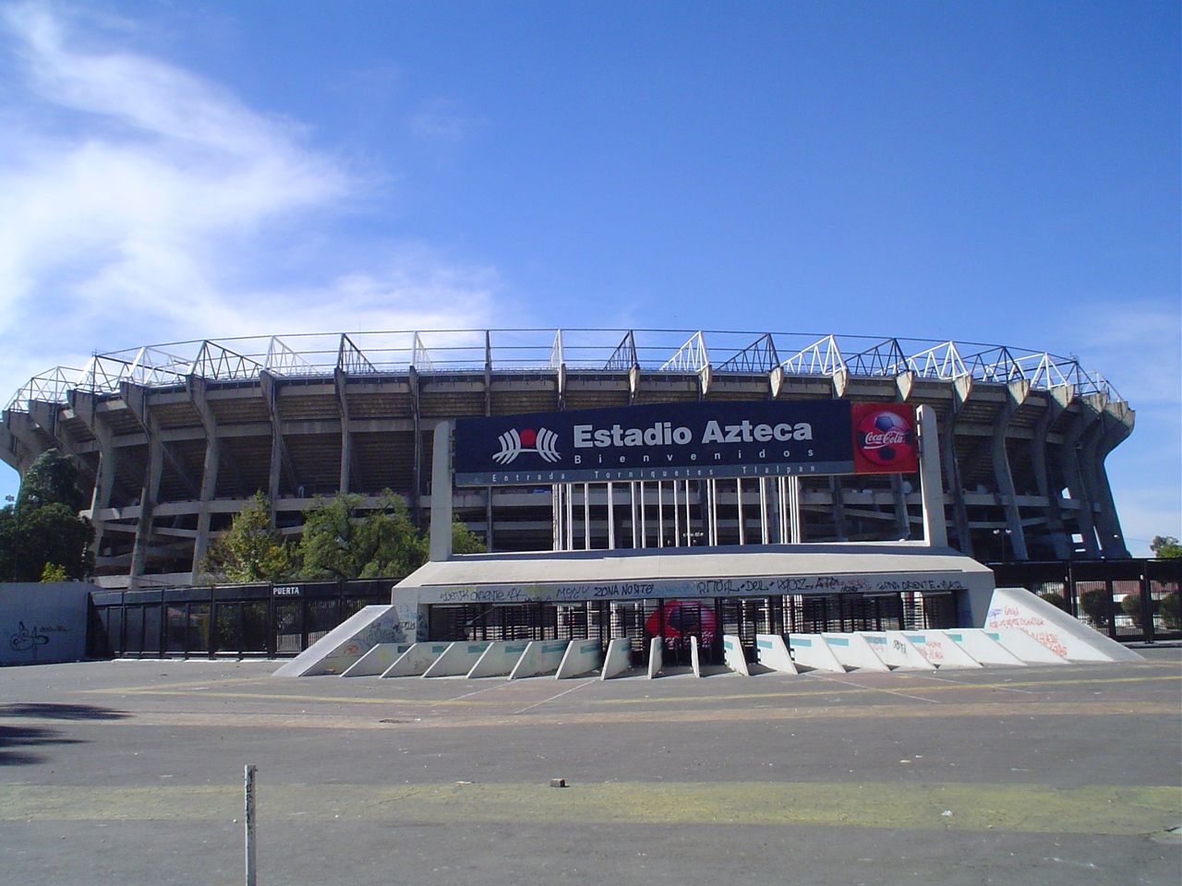https://www.youtube.com/watch?v=ZuX7499mIvo
- https://www.espn.com/soccer/story/_/id/37497919/estadio-azteca-only-stadium-three-world-cups-now-mexico-co-host-2026
- https://en.wikipedia.org/wiki/Estadio_Azteca
- https://stadiumdb.com/tournaments/world_cup/2026/estadio_azteca
- https://www.espn.com/soccer/story/_/id/45043353/renovated-azteca-stadium-reopen-march-2026-world-cup
- https://www.foxsports.com/stories/soccer/world-cup-2026-fifa-reveals-record-16-host-cities-and-stadiums
- https://www.standardmedia.co.ke/business/football/article/2001489613/2026-world-cup-final-will-be-played-at-metlife-stadium-in-new-jersey
- https://www.goal.com/en-ke/lists/at-t-stadium-guide-history-stay-world-cup-2026/blt699c6b089e520b04
- https://atamerica.or.id/stadiums-in-america-for-world-cup/
- https://stadiumdb.com/tournaments/world_cup/2026
- https://www.bbc.com/sport/football/46138022
- https://www.reuters.com/sports/soccer/mexico-readies-historic-third-world-cup-azteca-stadium-tensions-grow-2025-06-11/
- https://footballbh.net/2024/05/07/estadio-azteca-mexican-football/
- https://www.goal.com/en-ke/lists/mexico-city-expecting-big-changes-to-the-estadio-azteca-and-surrounding-areas-ahead-of-the-2026-world-cup/bltd8c7ab61a4f4dd74

